Note of 19 January 1959
__________________________________________________________________________
MECHANICS — Experimental determination of the influence of the inclination of the bearing surface upon the movement of the paraconical pendulum with anisotropic support
Note (*) by Mr. Maurice Allais, presented by Mr. Albert Caquot.
___________
Comparison of the experimental results obtained by varying the inclination of the support surface of the paraconical pendulum, both during releases from a given azimuth, and during doubly enchained experiments, shows that the periodic variations of the azimuth over time cannot be considered to be a result of variations of the inclination of the support with respect to the vertical.
1. In order to determine the influence of the inclination of the support (¹), and to eliminate any systematic periodic influence, I performed successive experiments, with the surface of the support alternatively horizontal and inclined.
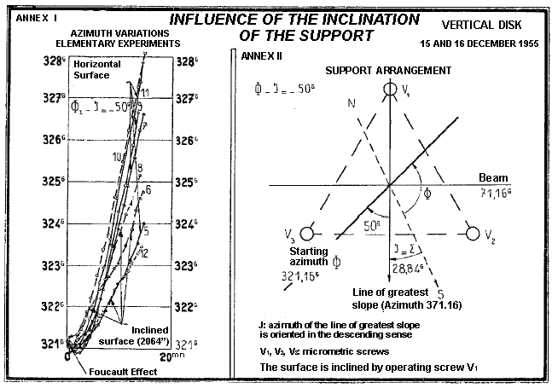
I define i as being the inclination of the support, and J as being the angle which the projection of the line of greatest slope (in the downward direction) makes with the North-South vector. The azimuth of the plane of oscillation is designated by Φ. In Annex II, I give the results obtained on the 15th and 16th of December 1955
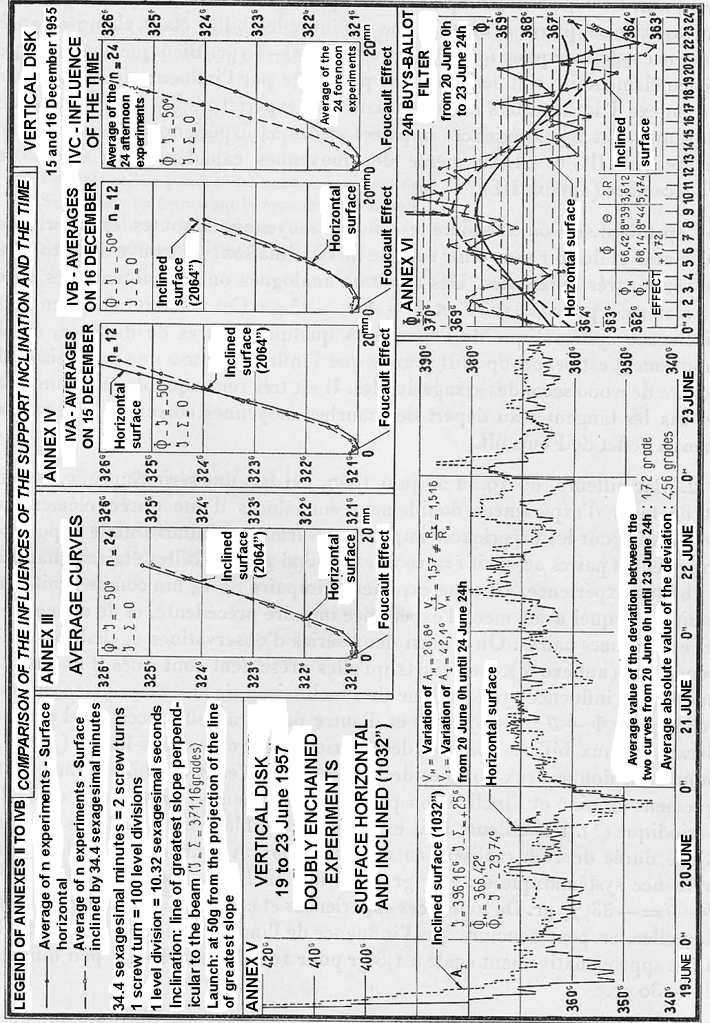
for 48 experiments of 14 mn with the pendulum P₁ (²), of which the odd-numbered experiments corresponded to a horizontal surface and the even-numbered experiments corresponded to an inclined surface, with the balls being changed for each experiment, and with i=2064" and Φ-J=-50 grades. Although each elementary experiment was seriously perturbed by the influence of the balls (see in annex I the results corresponding to the experiments 5 to 12), the average curves of the 24 odd-numbered experiments and of the 24 even-numbered experiments are little different. The same holds for the averages calculated for the 15th and 16th of December (annex III).
However, if one considers the average curves for all the experiments in the morning and in the evening without considering the inclination, one finds two average curves which are very different. Analogous results were obtained on the 22nd and 24th of May 1957, for i=1032" and Φ-J=-25 grades. These results show that the systematic influence of the epoch, at a distance of several hours, upon the movement is much greater than the influence due to an inclination of the order of 2000 sexagesimal seconds. It is very remarkable that in all cases the initial tangents to the average curves corresponded exactly to the Foucault effect.
2. Moreover, from the 19th to the 23rd of June 1957, I performed a continuous series, day and night, of doubly enchained experiments which had an elementary duration of 14 mn. For the odd-numbered experiments the surface was horizontal, and for the even-numbered experiments I had i=1032", J=396 grades. The balls were changed for each experiment. Each odd-numbered experiment of 14 mn started at the azimuth at which the previous odd-numbered experiment had terminated, and similarly for the even-numbered experiments. Thus I had two independent series of enchained observations (annex V). The deviations which they present are partly due to a slight systematic influence of the inclination of the surface (1.72 grades for 1032", with Φ-J=-29.7 grades), and partly due to an accidental effect of preponderance ascribed to the balls. For these two series, the Buys-Ballot filter (fig. VI) for 24 hours gives two curves of the same tendency, the effect of the balls being practically eliminated and the inclination appearing to augment the amplitude of the periodic effect (³). Moreover, eight double enchained experiments, each of a duration of 10 h, performed over May-June 1957 showed a systematic influence of 2.77 grades for a double inclination of 2064" and Φ-J=-33.77 grades. From all these experiments, and taking account of accidental errors, one may conclude that the influence of the inclination is proportional to i and approximately equal to 1.5 grades for 1000", for Φ-J little different from -30 grades.
3. These numbers may be usefully compared with the results obtained in Bougival and St. Germain in July 1958. The amplitudes 2R of the effects which correspond to the filter of 24h 50mn were of the order of 2.15 grades, while the daily variations of the levels were never greater than 8" (⁴).
4. From all these indications it follows that the observed periodic effects cannot be attributed to variations of the inclination of the vertical.
(*) Session of 1 December 1958.
(¹) Proceedings, 244, 1957, p. 2469; 245, 1957, pp. 1697, 1875, 2001, and 2170; and 247, 1958, p. 1428.
(²) Pendulum used during the continuous experiments of 1954 and 1955.
(³) Undoubtedly by promoting the formation of ellipses.
(⁴) One should remember that the theoretical deviations of the vertical due to the luni-solar action are of the order of a hundredth of a sexagesimal second.
(Extract of the Proceedings of the Sessions of the Academy of Sciences,
t. 248, pp. 359-362, session of 19 January 1959.)

