Note of 18 November 1957
__________________________________________________________________________
MECHANICS — Movements of the paraconical pendulum and the total solar eclipse of 30 June 1954
Note (*) by Mr. Maurice Allais, presented by Mr. Albert Caquot.
___________
The plane of oscillation of a paraconical pendulum was displaced by about 15 grades at the moment of the total eclipse of the Sun of 30 June 1954. The forces which are brought into play are of the order of magnitude of those corresponding to the Foucault effect. It appears that the observed perturbation must be considered as resulting from an effect of the eclipse.
1. The present Communication proposes to detail the remarkable perturbations observed in the movement of a paraconical pendulum in our laboratory at Saint-Germain-en-Laye at the moment of the total eclipse of the Sun of 30 June 1954.
These perturbations took place during the 32-day series of chained observations over June-July 1954 (¹).
2. The experimental arrangements have been described previously; accordingly, I shall only mention that the pendulum whose movement was being observed was a paraconical pendulum (i.e. one suspended via a support ball) which was asymmetric, and consisted of a vertical bronze disk of 7.520 kg and two horizontal disks whose total weight was 7.700 kg.
The total weight of the pendulum was 19.8 kg. The length of the equivalent simple pendulum was 78.29 cm, and the period of oscillation was 1.775 seconds. The damping was about 11.5% over 14 minutes. The pendulum was released every 20 minutes with an initial amplitude of about 0.11 radian, and was observed for about 14 minutes.
3. The graphs shown hereinafter give the angular displacement of the plane of oscillation (shown along the ordinate) as a function of time (shown along the abscissa). Each point represents the initial azimuth corresponding to each series of observations of 14m, which was equal to the azimuth of the plane of oscillation at the end of the 14m of the previous experiment.
Graph A shows a curve representing the observed azimuths from 20h on 28 June 1954 to 4h on 1 July 1954, and also shows a curve symmetrical to the left part thereof about the vertical corresponding to 0h on 30 June.
GRAPH (A): TOTAL SOLAR ECLIPSE OF 30 JUNE 1954
OBSERVED AZIMUTHS OF THE PARACONICAL PENDULUM FROM 28 JUNE 20H TO 1 JULY 4H
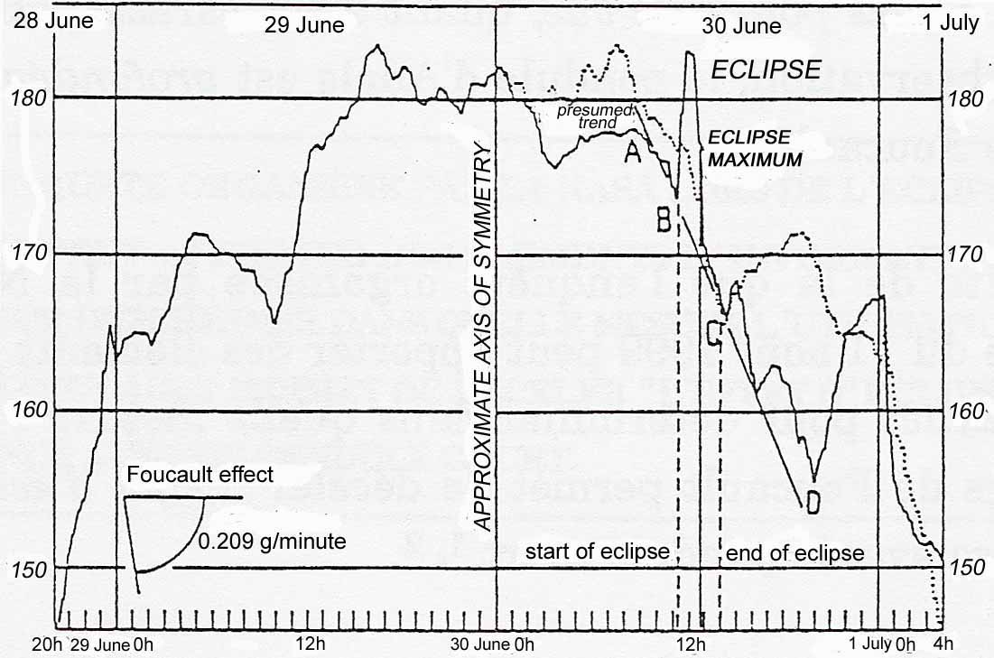
LEGEND
____________ Azimuths observed every 20 minutes
………… Curve symmetric to the solid curve on the left, with respect to 30 June 0h
GRAPH (B): TOTAL SOLAR ECLIPSE OF 30 JUNE 1954
OBSERVED AZIMUTHS OF THE PARACONICAL PENDULUM FROM 30 JUNE 9H TO 30 JUNE 15H
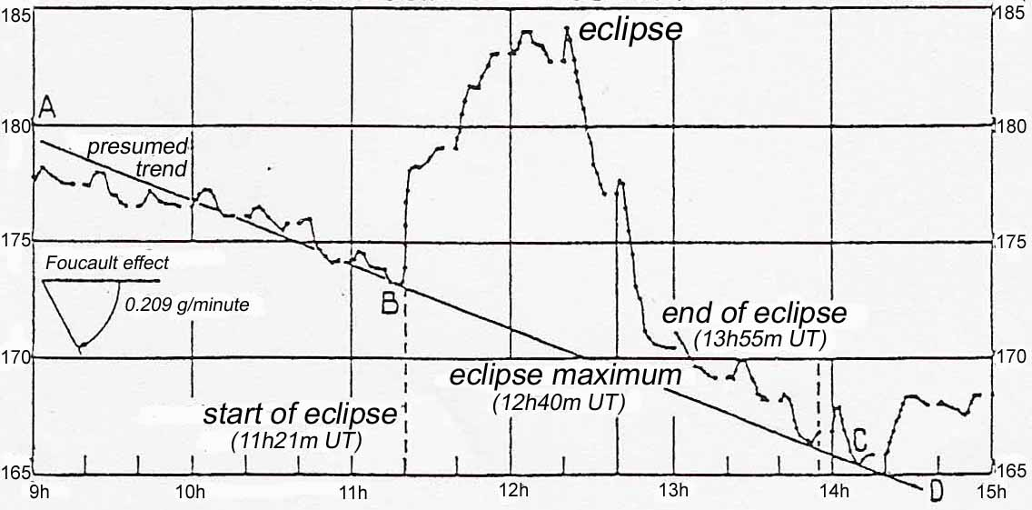
And Graph B shows an larger scale curve representing the observed azimuths from 9h on 30 June to 15h on 30 June (UT).
4. The eclipse started at 11h 21m and finished at 13h 55m. At the exact moment of the start of the eclipse, the azimuth of the plane of oscillation increased abruptly by 5 grades from the trend which previously had characterized its movement. And this deviation attained its maximum (of 15 grades) 20m before the maximum of the eclipse, which occurred at 12h 40m, and then it diminished progressively, but more abruptly than during the period of increase, with the deviation being only 1 grade 20' before the end of the eclipse.
It can be seen that after the eclipse, as far as can be judged, the displacement of the plane of oscillation again assumed a movement CD analogous to the movement AB which had been observed before the start of the eclipse (Graph B).
Graph A shows approximate symmetry of the curve of azimuths with respect to the vertical line corresponding to 0h on 30 June. This symmetry, which can be attributed to the periodic structure of the movement (¹), is evident over 28h. Suppose, as seems reasonable, that this symmetry corresponds to a physical reality which is independent of the perturbations caused by the contact of the support ball and surface; then it is clear that nothing in the portion of the curve of azimuths before the time at the center of symmetry corresponds to the very strong deviation observed during the eclipse.
I should also underline that, during all the seven periods of continuous observation which have been performed (¹), I have never observed any variation of the curve of azimuths like the part BC which corresponds to the solar eclipse of 30 June 1954 (see for example, in Graph B, the curve portions from B to C on the one hand, and from A to B and from C to D on the other hand) (²).
5. Finally, one may remark that the rapid variations of azimuth observed from 11h 20m to 12h and from 12h 20m to 13h correspond to angular speeds of the order of 0.62·10⁻⁴ and 0.79.10⁻⁴ rad/s, i.e. respectively 1.13 and 1.43 times the Foucault effect (which is 0.55.10⁻⁴ rad/s at the latitude of our laboratory at Saint-Germain). The forces brought into play during the observed perturbations are accordingly of the same order of magnitude as those which cause the Foucault effect.
6. Especially in the light of the previous descriptions of regularities observed in the movement of the paraconical pendulum (¹), it seems to me to be an inescapable conclusion that the observed perturbation is effectively due to the effect of the eclipse.
(*) Session of 18 November 1957.
(¹) Proceedings, 245, 1957, pp. 1697 and 1875.
(²) It is remarkable that the maximum value of the apparent deviation due to the eclipse took place 20m before the maximum of the eclipse. There is therefore a certain asymmetry in the observed effect. A similar asymmetry was observed for terrestrial magnetism, but in the opposite sense, with the maximum of the effect being later than the eclipse maximum (Lion, Proceedings, 33, 1851, p. 202; 34, 1852, p. 207; Lion and Muller, Proceedings, 74, 1874, p. 199) and for the terrestrial electric field (Nordmann, Proceedings, 142, 1906, p. 40; Chevrier, Proceedings, 197, 1933, p. 1143; Rouch, Proceedings, 239, 1954, p. 465).
(Extract of the Proceedings of the Sessions of the Academy of Sciences,
t. 245, pp. 2001-2003, session of 4 December 1957.)

