THE ALLAIS PENDULUM IS TOTALLY DIFFERENT FROM THE FOUCAULT PENDULUM
THE STRUCTURE OF THE PENDULUM IS DIFFERENT, THE SUPPORT IS DIFFERENT, AND THE OBSERVATIONAL PROCEDURE IS DIFFERENT

THE MOVEMENTS OF THE ALLAIS PENDULUM ARE TOTALLY DIFFERENT FROM THOSE OF THE FOUCAULT PENDULUM
Graph IV
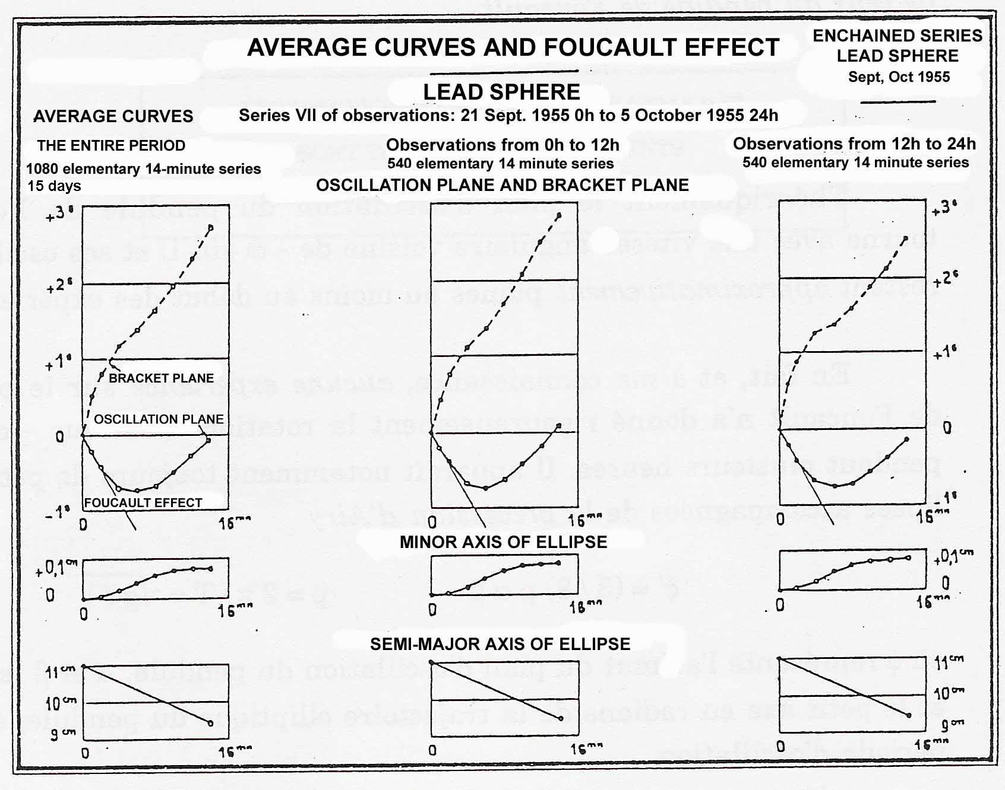
Legend: azimuth of the plane of oscillation; azimuth of the principal trihedral of inertia
Source: Graph III A 1 of my Conference of 22 February 1958
The Anisotropy of Space, p. 95.
AT THE START OF EACH 14 MINUTE EXPERIMENT, IT IS SEEN THAT THE TANGENT AT THE BEGINNING OF THE GRAPH REPRESENTING THE AZIMUTH CORRESPONDS EXACTLY TO THE FOUCAULT EFFECT.

THE ENQUIRY ORGANIZED BY NASA UPON THE OCCASION OF THE TOTAL ECLIPSE OF 11 AUGUST 1999 MAY RESULT IN EXTREMELY USEFUL DATA FOR ELUCIDATING THE EXTENT TO WHICH LONG FOUCAULT PENDULUMS CAN EXHIBIT THE "ECLIPSE EFFECT" WHICH I DEMONSTRATED WITH A SHORT PENDULUM
GRAPH XXIX: TOTAL SOLAR ECLIPSE OF 30 JUNE 1954
OBSERVED AZIMUTHS OF THE PARACONICAL PENDULUM FROM 28 JUNE 20H TO 1 JULY 4H
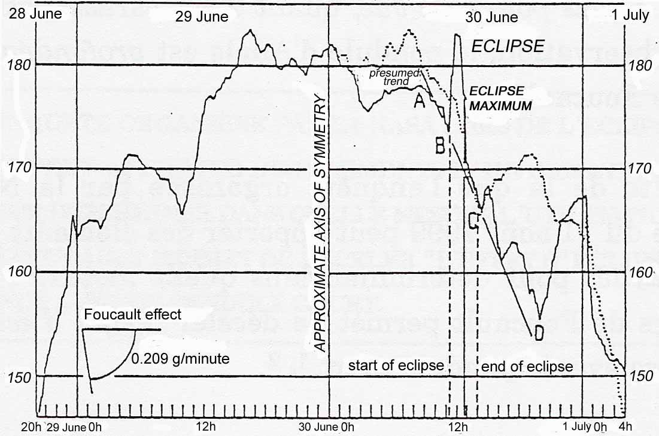
LEGEND
____________ Azimuths observed every 20 minutes
………… Curve symmetric to the solid curve on the left, with respect to 30 June 0h
GRAPH XXX: TOTAL SOLAR ECLIPSE OF 30 JUNE 1954
OBSERVED AZIMUTHS OF THE PARACONICAL PENDULUM FROM 30 JUNE 9H TO 30 JUNE 15H
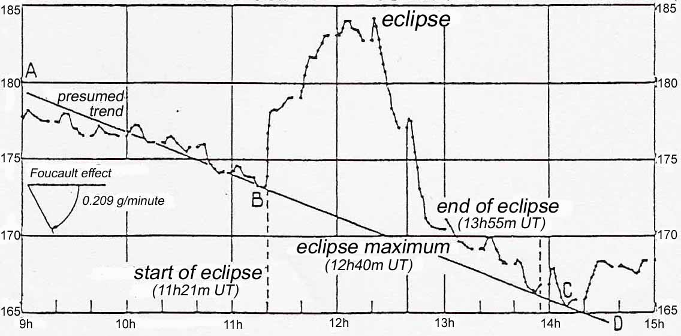
Source: Note of 4 December 1957 to the Academy of Sciences - Movements of the paraconical pendulum and the total solar eclipse of 30 June 1954, CRAS, vol. 245, pp. 2001-2003
The Anisotropy of Space, p. 165
Graph XXXIII
COMPARISON OF THE AZIMUTHS OBSERVED
DURING THE TWO ECLIPSES
OF 30 JUNE 1954 AND 2 OCTOBER 1959
___________________________
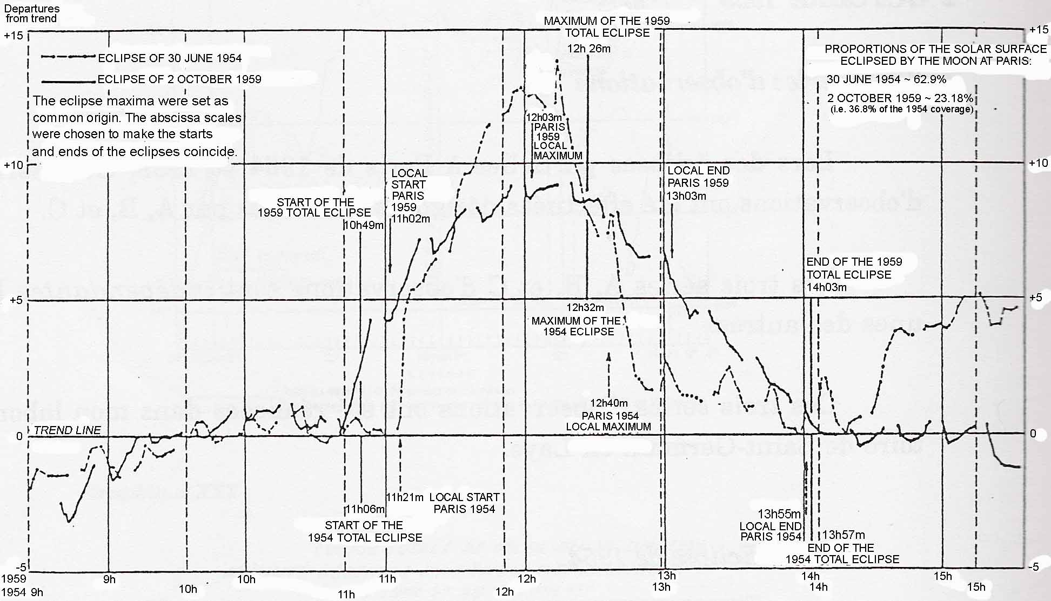
Source: Allais, unpublished note of 10 November 1959, Movement of the paraconical pendulum and the total solar eclipse of 2 October 1959
The Anisotropy of Space, p. 170

Graph XXIII
PARACONICAL PENDULUM WITH ISOTROPIC SUPPORT
Chained Series
28 September 1959, 16h 20m — 4 October 1959, 3h 40m
Hourly azimuths φ in grades
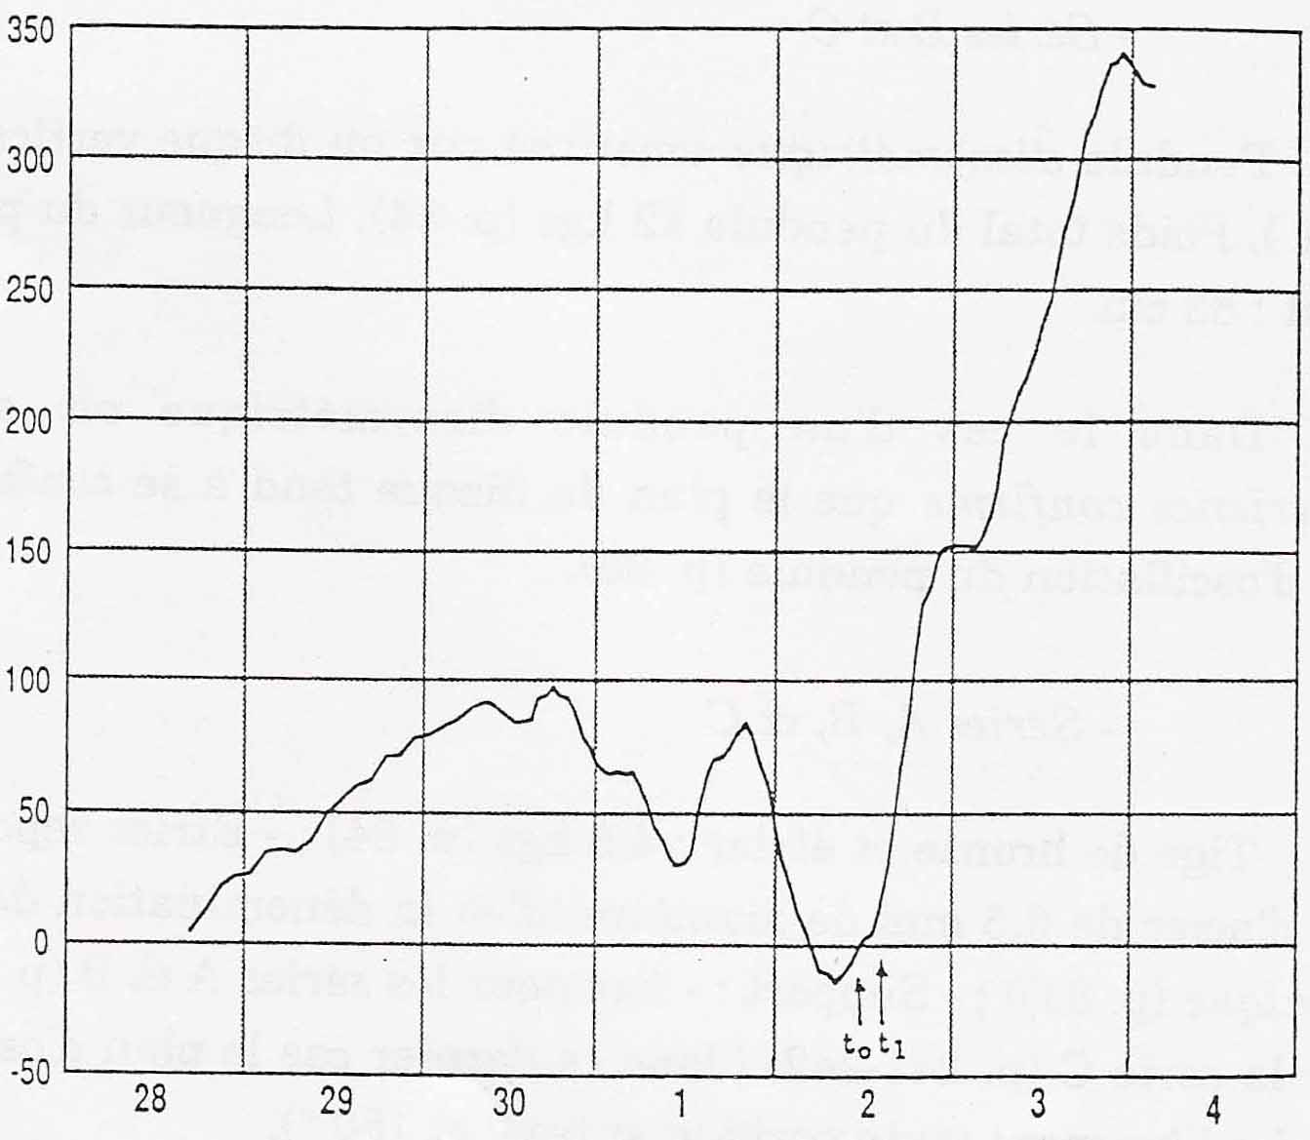
September October
Legend: t₀ and t₁ – beginning and end of the total solar eclipse of 2 October 1959
Azimuths 0 and 200 grades correspond to the meridian.
Azimuths 100 and 300 grades correspond to the East-West direction.
Sources: Graph 8617 (20 May 1996) and Table 7461 (4 November 1982)
Isotropic Support
The Anisotropy of Space, p. 318
DURING THE THREE SERIES OF OBSERVATIONS, EACH INDEPENDENT FROM THE OTHERS, THE BEHAVIOR OF THE PARACONICAL PENDULUM WAS ABSOLUTELY COMPATIBLE WITH ITS BEHAVIOR IN THE MOST GENERAL CASE: A TENDENCY OF THE PLANE OF OSCILLATION OF THE PENDULUM TO APPROACH A LIMIT DIRECTION, VARIABLE OVER TIME, RESULTING FROM BOTH THE ANISOTROPY OF SPACE AND THE ANISOTROPY OF THE SUPPORT.
THE ECLIPSE EFFECT IS ONLY A VERY PARTICULAR CASE OF A MUCH MORE GENERAL PHENOMENON: THE EXISTENCE AT EACH INSTANT OF A DIRECTION OF ANISOTROPY OF SPACE, VARIABLE OVER TIME, TO WHICH THE PLANE OF OSCILLATION OF THE PENDULUM TENDS TO APPROACH DURING EACH ELEMENTARY EXPERIMENT OF 14 MINUTES.
DURING A TOTAL SOLAR ECLIPSE, THE DIRECTION OF ANISOTROPY OF SPACE BECOMES COINCIDENT WITH WITH THE EARTH – MOON – SUN LINE.
ALTHOUGH IT MAY BE VERY SPECTACULAR, THE ECLIPSE EFFECT IS MUCH LESS SIGNIFICANT THAN THE EFFECTS OF THE ANISOTROPY OF SPACE, AS DEMONSTRATED BY MY EXPERIMENTS WITH THE PARACONICAL PENDULUM WITH ANISOTROPIC SUPPORT AND WITH ISOTROPIC SUPPORT
Table 1
Asymmetrical Paraconical Pendulum with Anisotropic Support
Month-long Chained Experiments 1954-1960
Azimuths and periodic components of 24 and 25 hours in grades and in degrees
Σ = Azimuth of anisotropy of the support = 171.16 grades = 154.04 degrees
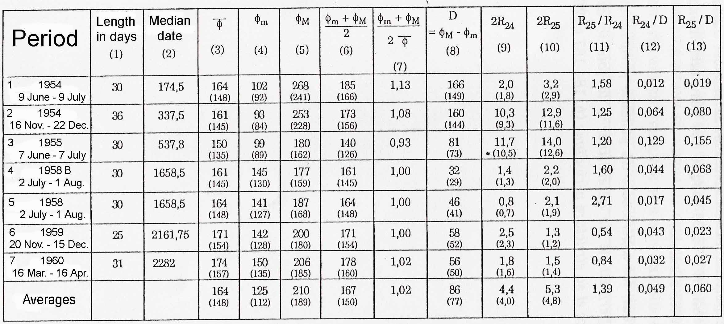
Notes: 1. All the experiments were performed at IRSID at Saint-Germain, except experiment 4 which was performed at Bougival.
2. The angular measurements are given in grades. Angles are reckoned from the North in the prograde sense. Measurements in degrees are shown in parentheses.
3. The median date of each month-long series is reckoned in days, starting at 1 January 1954.
4. φ_{m} and φ_{M} are the minimum and maximum values of the azimuth of the plane of oscillation. φ is the average value of the azimuths φ.

The Anisotropy of Space, p. 92.

Note: In view of the very limited means of calculation which were available at the time, the calculations were made using 25h instead of 24h 50m. This approximation is acceptable as far as orders of magnitude are concerned.
Graph I
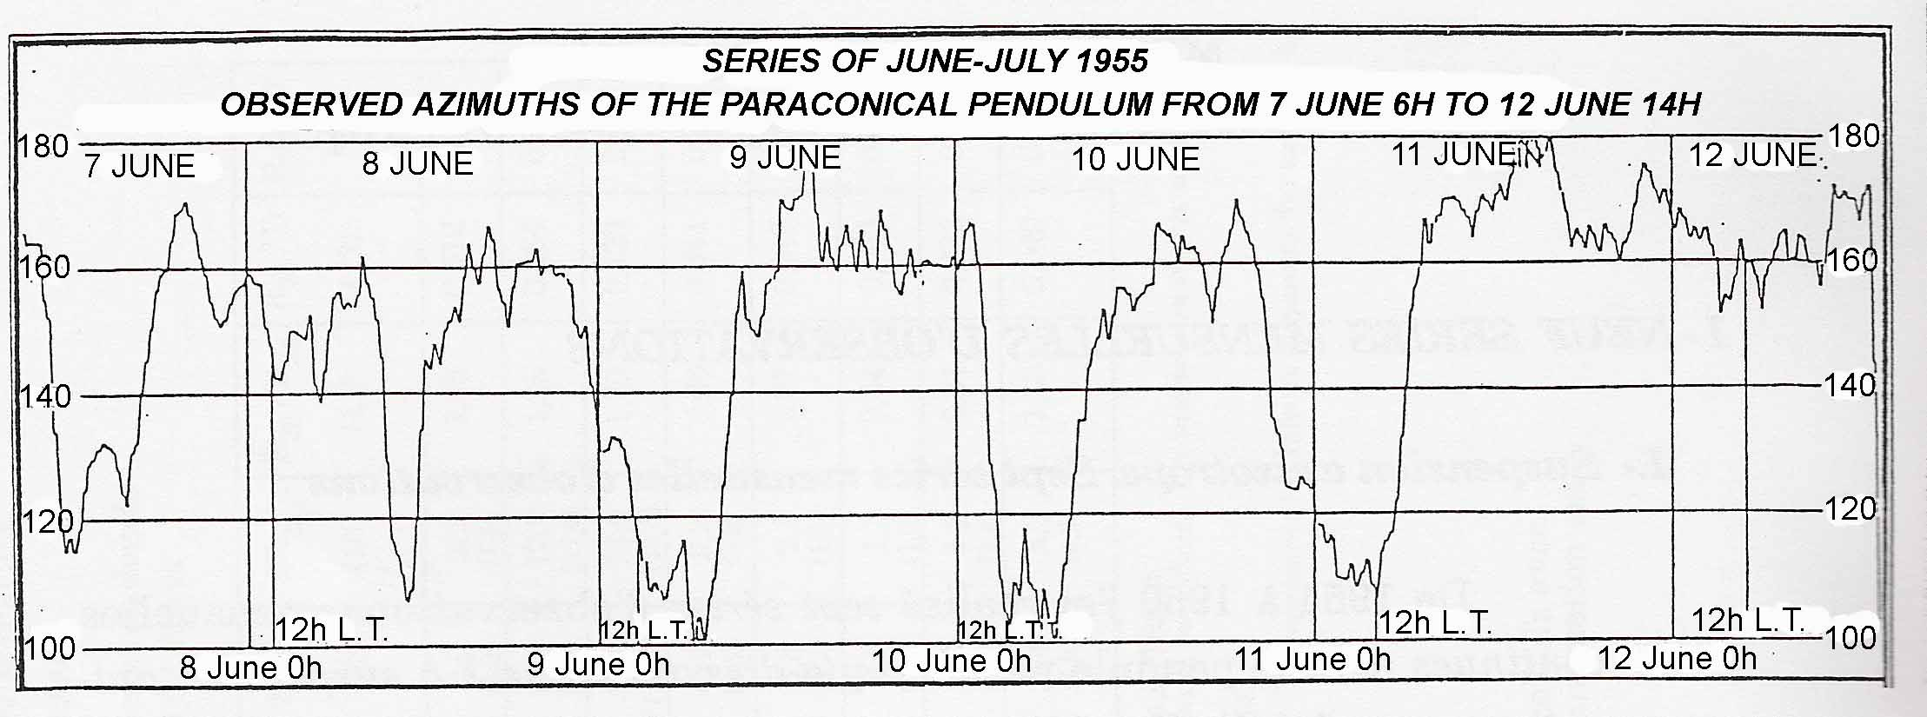
Legend: the angles are reckoned in grades from the North in the prograde sense.
An azimuth of 100 grades corresponds to the direction perpendicular to the meridian. An azimuth of 200 grades corresponds to the meridian
12h L.T.: moment of the passage of the Moon over the meridian..
Sources: Note to the Academy of Sciences of 18 November 1957, "Harmonic analysis of the movements of the paraconical pendulum"; and Graph IIIA of my Conference of 22 February 1958.
The Anisotropy of Space, p. 88.
Graph I ISOTROPIC SUSPENSION
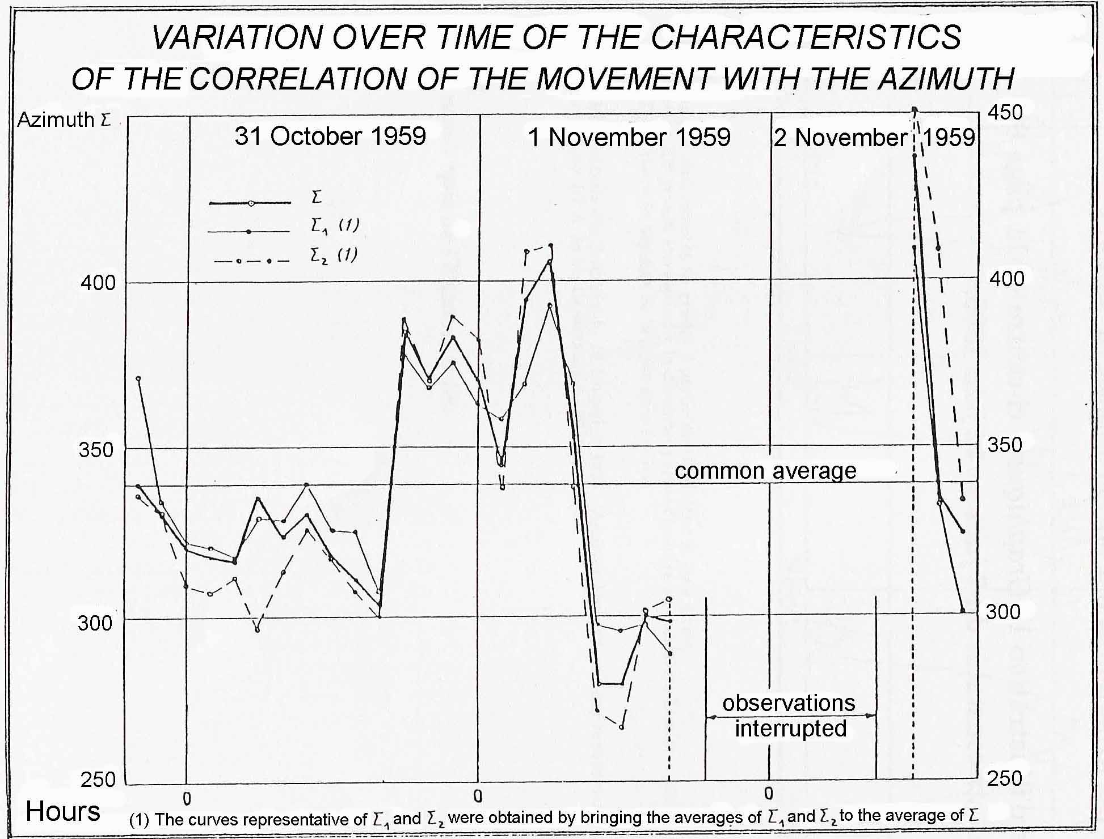
Source: my Note of 10 November 1959 (see Source of Table II)
The Anisotropy of Space, p. 252.
Legend: see Table II, p. 251.
φ=a₀ + a₁ sin 2(φ-Σ₁) + a₂ sin 4(φ-Σ₂)
The angles Σ₁ and Σ₂ are neighbors. The
same holds for the coefficients a₁ and a₂.

Graph VI
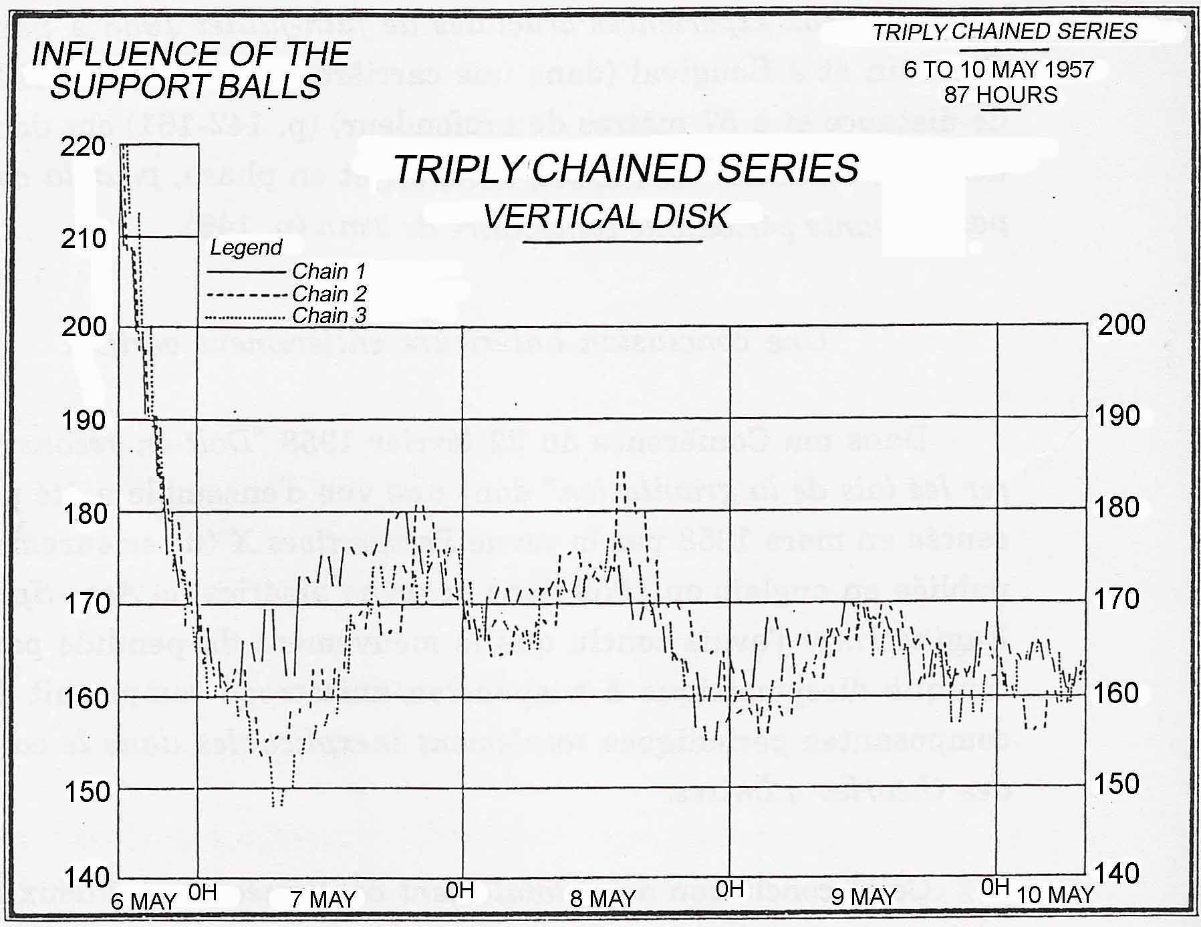
Source: Graph IV A 2 of my Conference of 22 February 1958.
The Anisotropy of Space, p. 104.
Convergence to a limit plane variable over time is demonstrated by the three independent series of chained observations (for each series, the starting point at the instant t is the azimuth attained at the instant t-60 minutes)
Table X ANISOTROPY OF THE SUPPORT
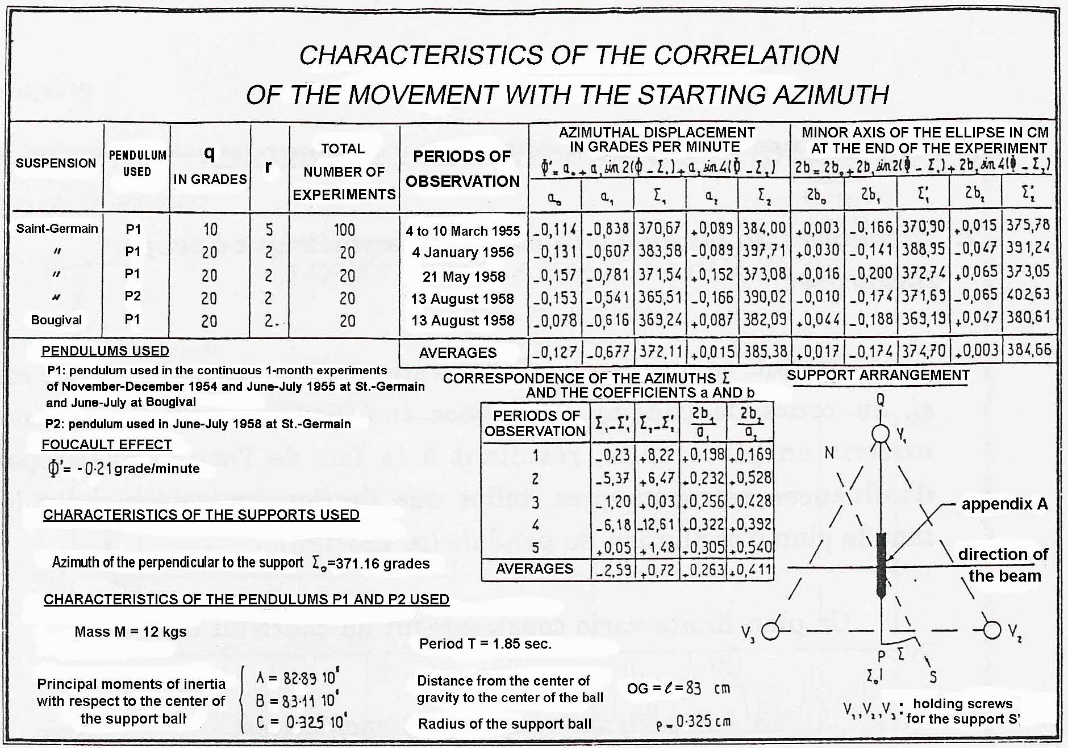
Source: Graph IV.B.2 of my Conference of 7 November 1959, and my Note of 9 February 1957 to the Academy of Sciences, Experimental determination of the influence of anisotropy of the support on the movement of the paraconical pendulum.
Graph XXXIV ANISOTROPY OF THE SUPPORT
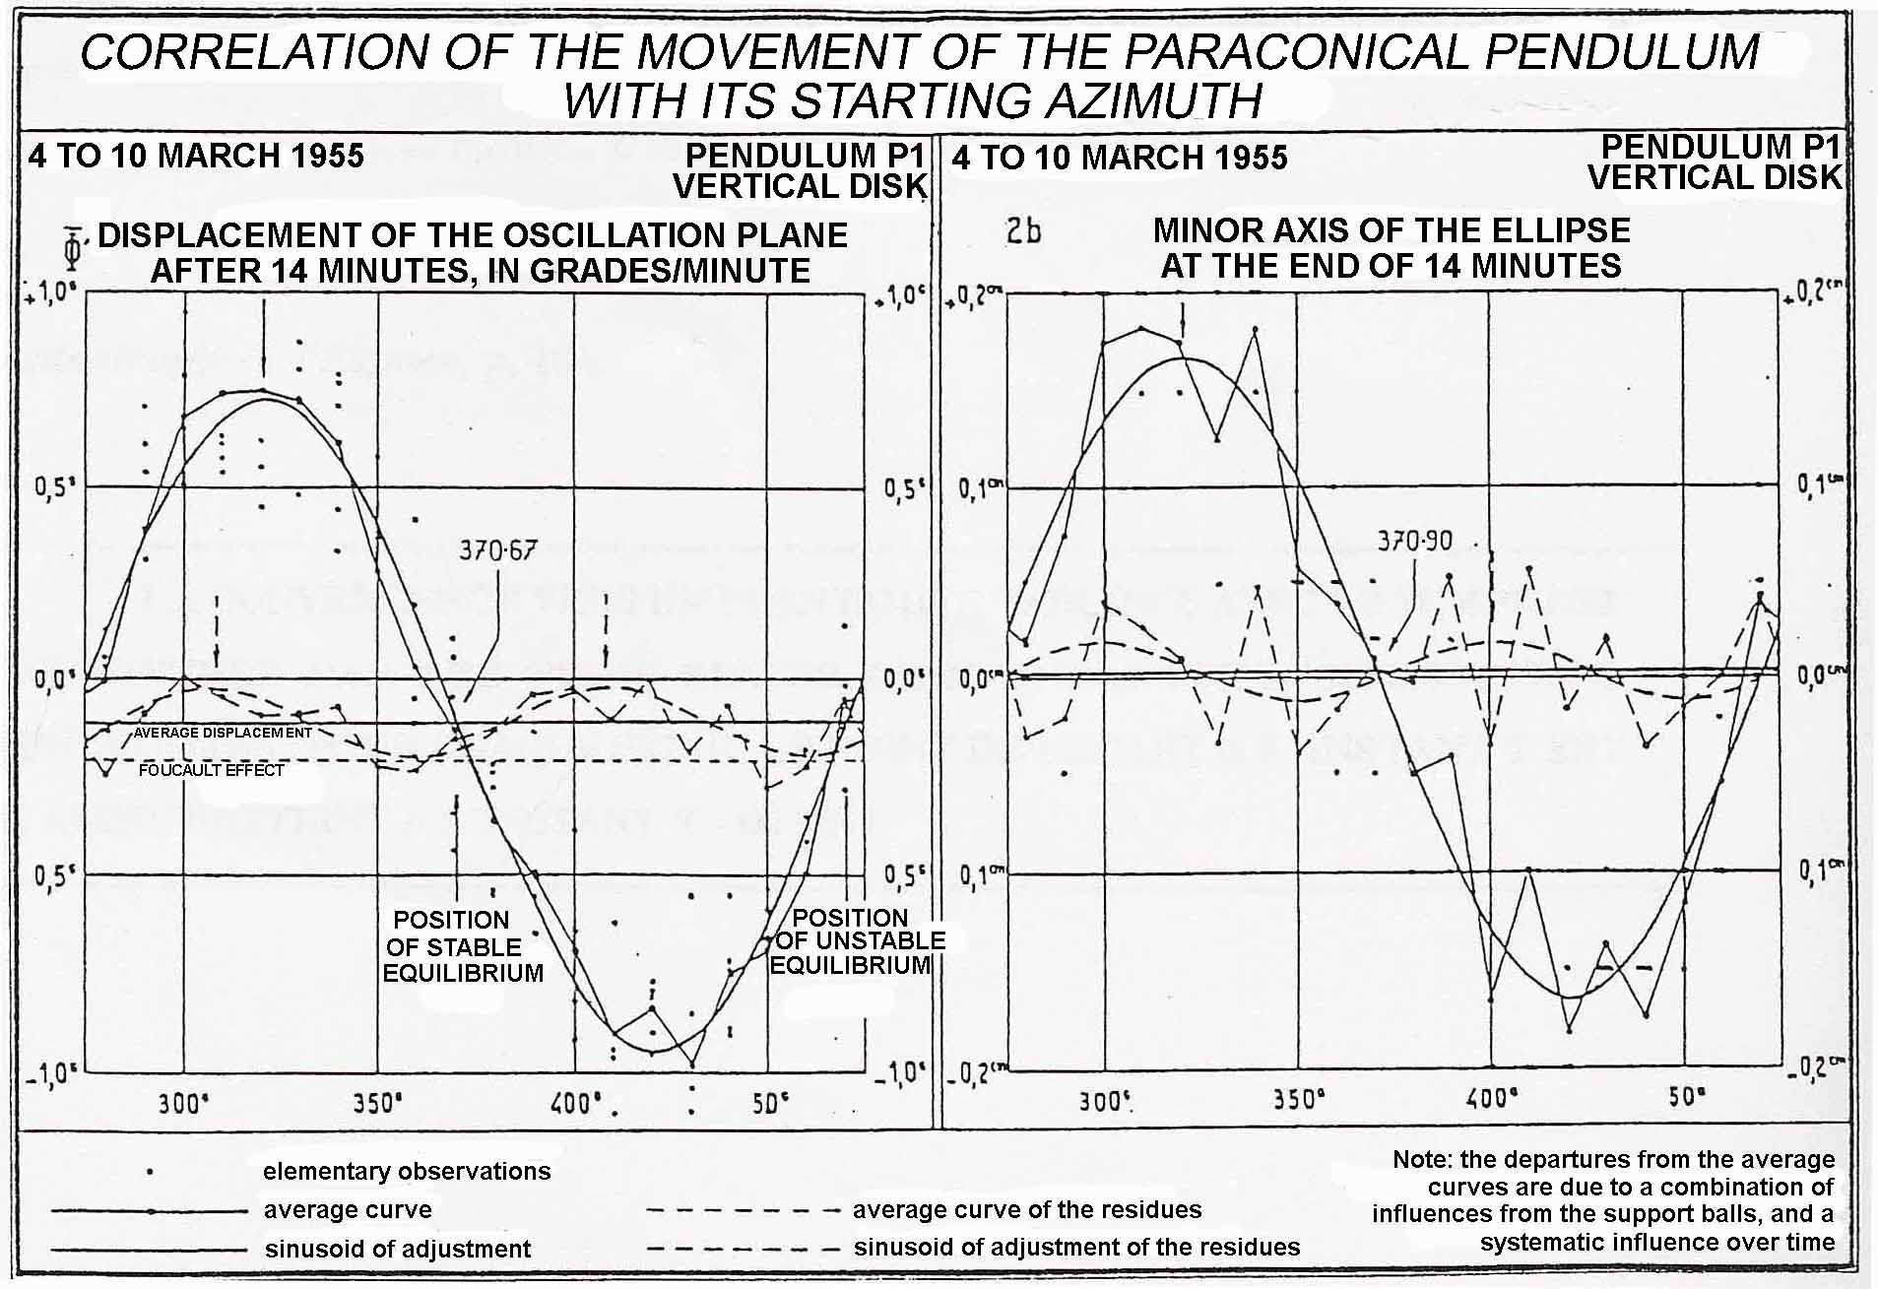
Source: Graph IV.B.1 of my Conference of 7 November 1959, and my Note of 9 February 1957 to the Academy of Sciences, Experimental determination of the influence of anisotropy of the support on the movement of the paraconical pendulum.
The Anisotropy of Space, pp. 180-181.

Graph II
PARACONICAL PENDULUM WITH ISOTROPIC SUPPORT
AZIMUTH OF THE DIRECTION OF ANISOTROPY OF SPACE
determined from the month-long series of observations
20 November 18h — 15 December 6h, 1959
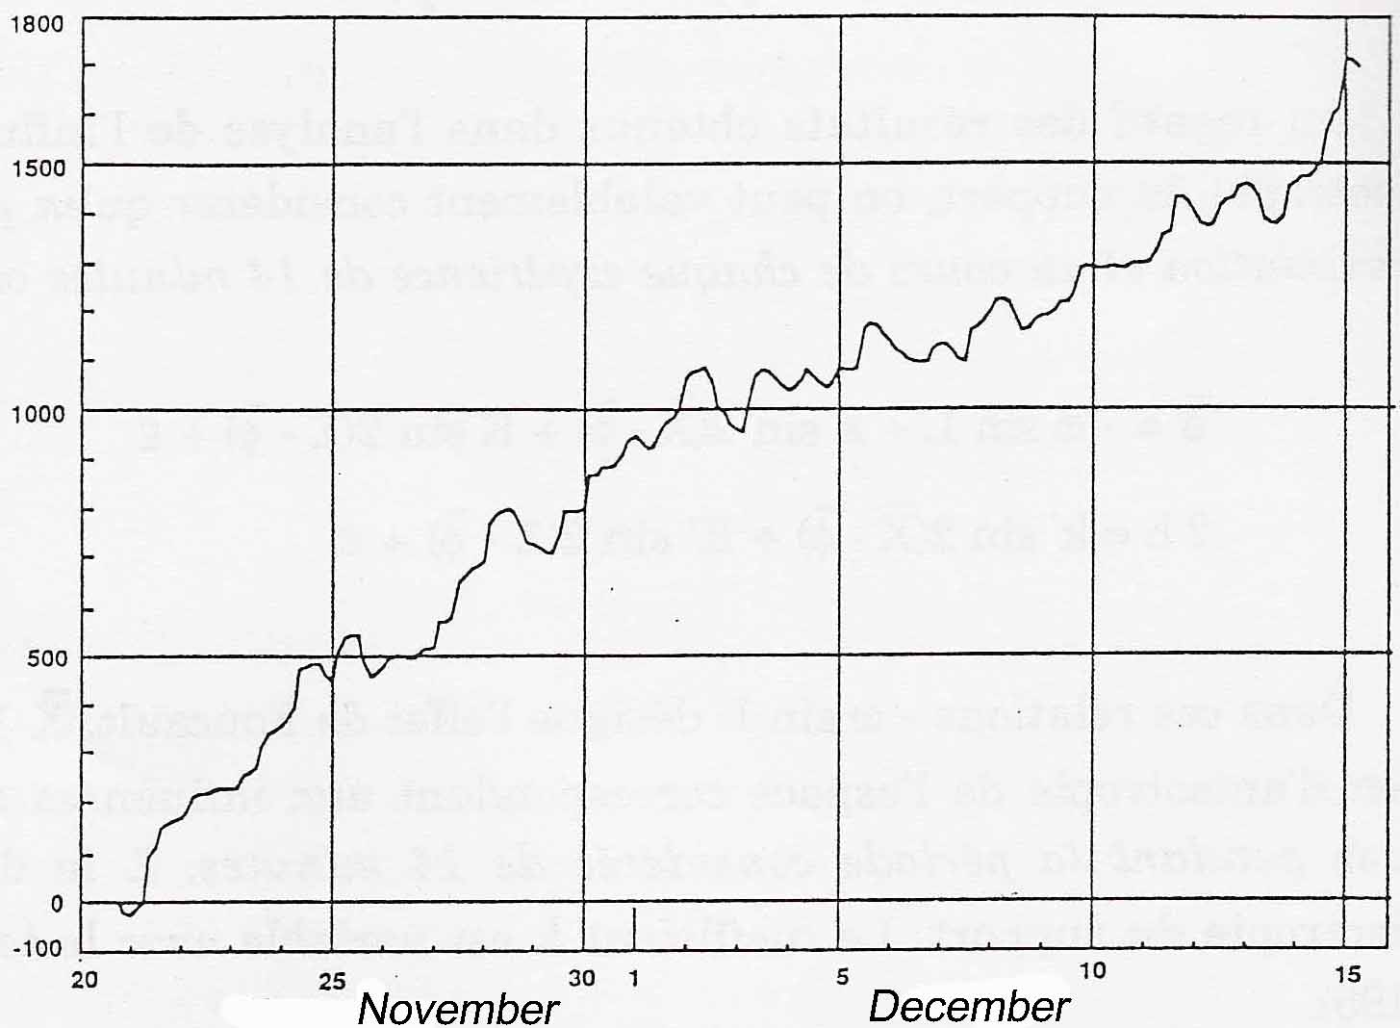
Legend: N = 197 relevant values of the azimuth of anisotropy from 3h to 3h. The azimuths
are reckoned in grades from the South, positively in the prograde sense.
Source: Graph 10842 and Table 12708 (18 October 1985)
Graph III
PARACONICAL PENDULUM WITH ISOTROPIC SUPPORT
AZIMUTH OF THE DIRECTION OF ANISOTROPY OF SPACE
determined from the month-long series of observations
16 March 21h — 15 April 18h, 1960
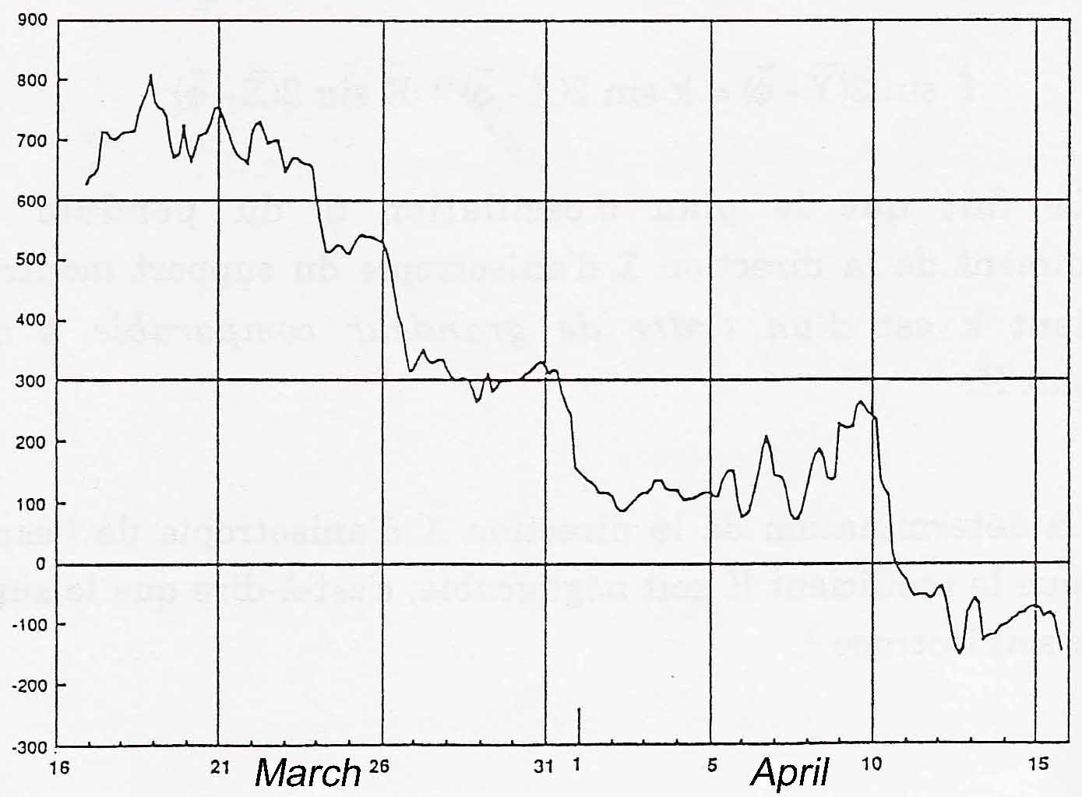
Legend: N = 240 relevant values of the azimuth of anisotropy from 3h to 3h. The azimuths
are reckoned in grades from the South, positively in the prograde sense.
Source: Graph 10977 and Table 12705 (19 December 1985)
The Anisotropy of Space, pp. 261-262.

THE VARIATIONS OVER TIME OF THE ANISOTROPY OF SPACE ARE DETERMINED BY THE MOVEMENTS OF CELESTIAL BODIES, AND IN PARTICULAR BY THE RELATIVE MOVEMENTS OF THE SUN AND THE MOON.
Graph V
AZIMUTH OF THE PARACONICAL PENDULUM
Month-long series of June-July 1955
Adjustment by the Buys-Ballot method
to a wave of 25h
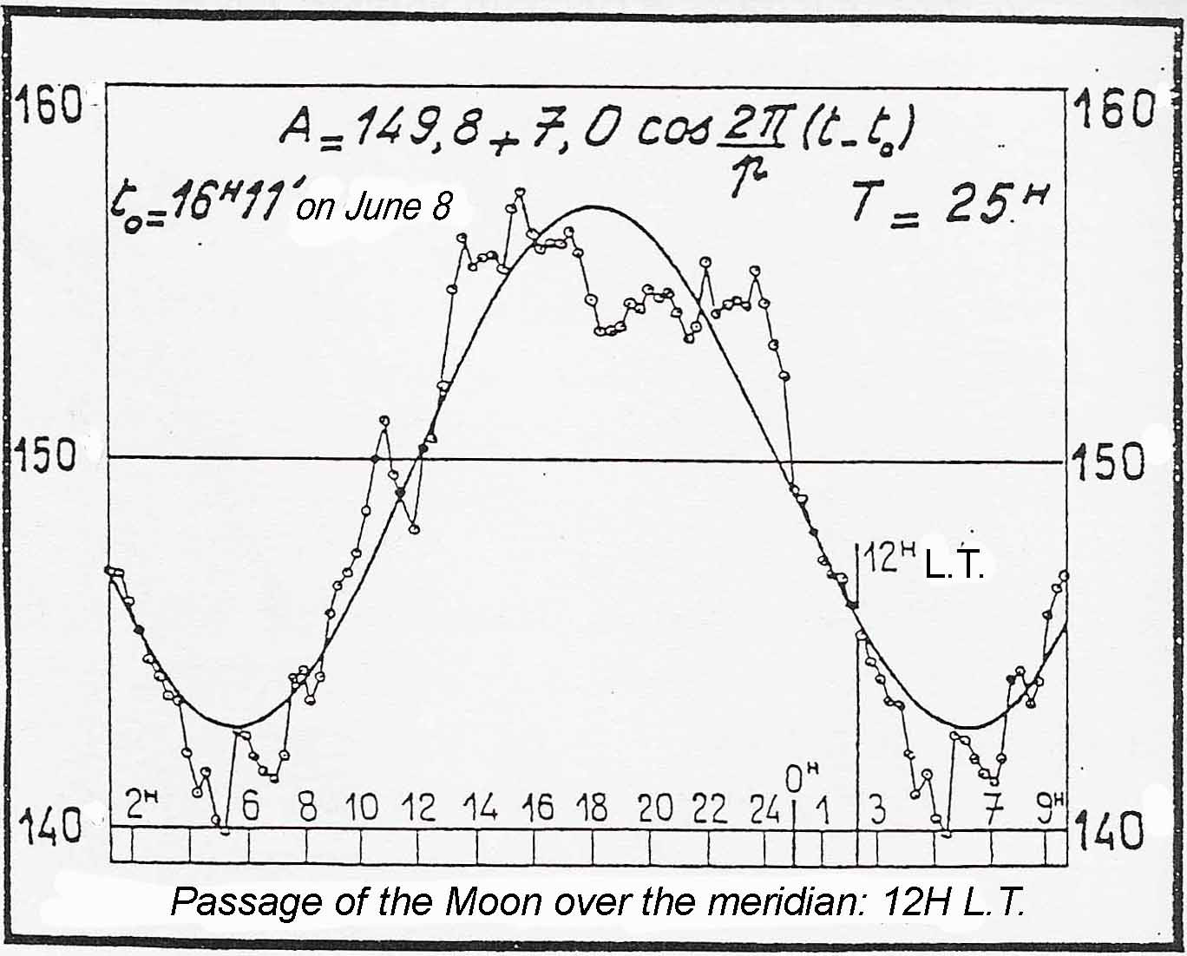
Source: My Note of 25 November 1957 to the Academy of Sciences, Harmonic Analysis of the Movements of the Paraconical Pendulum, and Graph IIIA of my Conference of 22 February 1958.
The Anisotropy of Space, p. 100.
TO AN AMPLITUDE OF 14 GRADES IN 25 HOURS, THERE CORRESPONDS AN AVERAGE PERIODIC COMPONENT
14 π
φ' = _________________ ____ rad/sec
25 · 60 · 60 200
= 0.244 · 10⁻⁵ rad/sec
Table II
AZIMUTH OF THE PARACONICAL PENDULUM AND ATMOSPHERIC PRESSURE
Month-long series of June-July 1955
Adjustment to the 13 periods of the theory of tides
Hydrographic Service of Paris and Hydrographic Institute of Hamburg
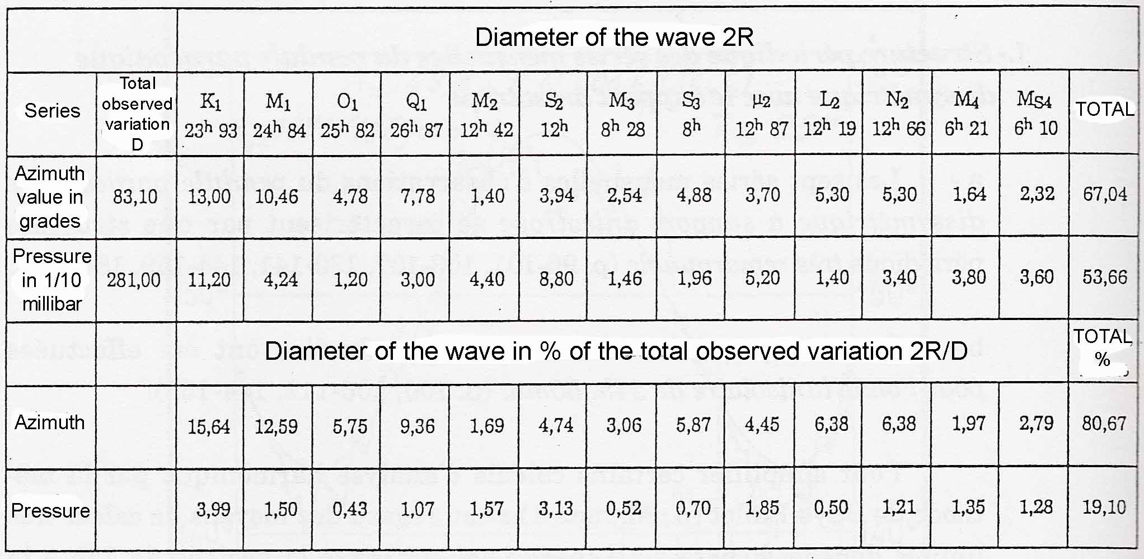
Source: My Note of 25 November 1957 to the Academy of Sciences, Harmonic Analysis of the Movements of the Paraconical Pendulum, and Table IIIA of my Conference of 22 February 1958.
The Anisotropy of Space, p. 99.
Table V
DISPLACEMENTS OF THE PLANE OF OSCILLATION OF THE PARACONICAL PENDULUM
IN HUNDREDTHS OF A GRADE PER MINUTE FROM THE MERIDIAN
DIURNAL AND SEMI-DIURNAL LUNI-SOLAR EFFECTS
Observed amplitudes and coefficients of the luni-solar periodicities
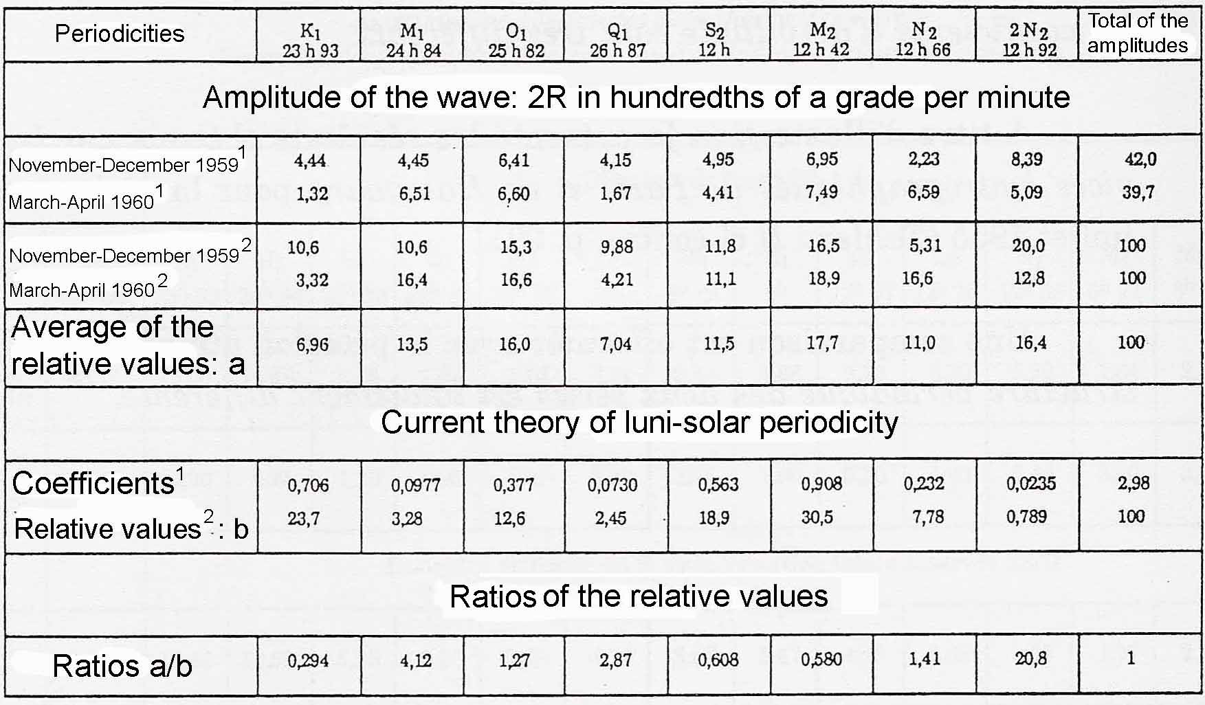
Legend: (1) Absolute values. The amplitudes in grades per minute corresponding to the paraconical pendulum are multiplied by 100.
(2) Relative values = absolute values / total of the amplitudes (or the coefficients)
Source: (1) Displacements of the azimuth of the plane of oscillation of the paraconical pendulum in the meridian plane (Tables 6629 and 6630 of 1960)
(2) Coefficients of the current theory of luni-solar periodicities: see Table IV of § E.1
The Anisotropy of Space, The paraconical pendulum with isotropic support, p. 287.
FOR THE PARACONICAL PENDULUM WITH ISOTROPIC SUPPORT, THE RATIO OF THE COMPONENT OF 24H 50M TO THE COMPONENT OF 24H IS ABOUT 14 TIMES LARGER, THAN WITH THE THEORY OF TIDES (4.12/0.294=14.01)

Graph XXVI
OBSERVATIONS IN JULY 1958 AT BOUGIVAL
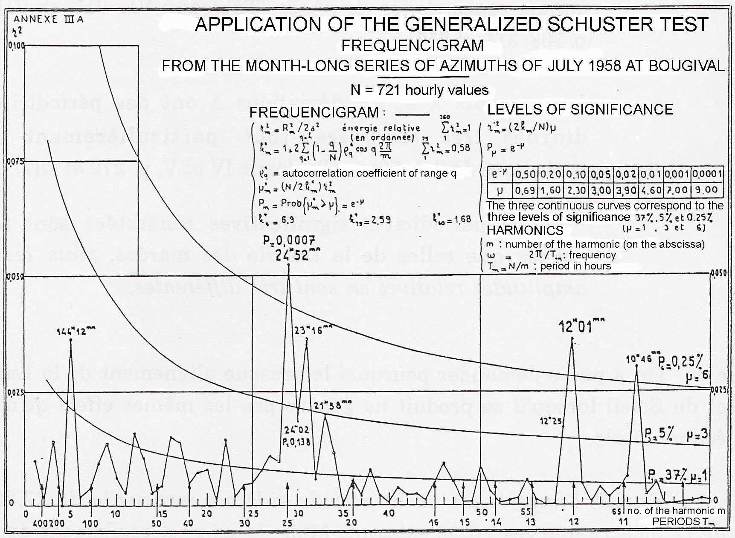
Legend: For the formulation of the test, see §B.1.3 above and the Legend of Graph XI.
Source: Annex IIIA of my Communication of 1961 to the International Institute of Statistics (see Source of Graph XXII).
The Anisotropy of Space, p. 156.
THE PROBABILITY OF OBTAINING THE OBSERVED AMPLITUDE FOR THE LUNI-SOLAR COMPONENT OF 24H 50M BY CHANCE IS ONLY 0.07%
NO PREVIOUS EXPERIMENTER HAS EVER INVESTIGATED, OR ATTEMPTED TO INVESTIGATE, THE PERIODIC STRUCTURE OF THE MOVEMENTS OF A PENDULUM, AND IN PARTICULAR ITS LUNI-SOLAR COMPONENTS.
FOR THE LUNI-SOLAR WAVE OF 24H 30M, IN THE CASE OF THE PARACONICAL PENDULUM WITH ANISOTROPIC SUPPORT, THE EFFECTS OBSERVED ARE ABOUT TWENTY MILLION TIMES GREATER THAN THOSE CALCULATED.
IN THE CASE OF THE PARACONICAL PENDULUM WITH ISOTROPIC SUPPORT, THE RATIO BETWEEN THE OBSERVED EFFECTS AND THE CALCULATED EFFECTS IS ABOUT A HUNDRED MILLION.
THESE DIFFERENCES BETWEEN THE CALCULATED VALUES AND THE OBSERVED VALUES ARE ENORMOUS, AND WITHOUT ANY EQUAL IN THE LITERATURE.
Table V
FORCES ACTING UPON THE FOUCAULT PENDULUM
DUE TO THE ATTRACTION OF CELESTIAL BODY i
RELATIVE TO AXES FIXED W.R.T. THE EARTH
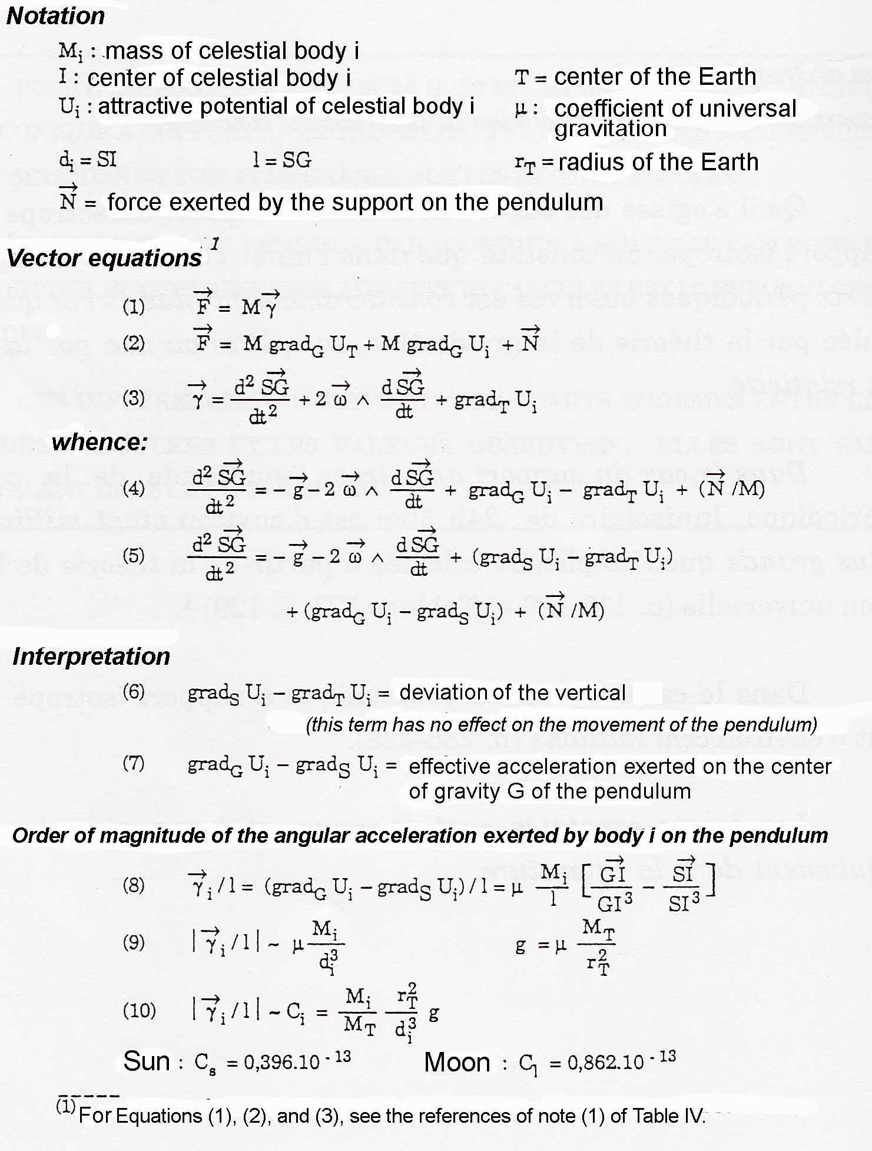
The Anisotropy of Space, p. 127
Component (6) is of the order of 10⁻⁸
Component (7) is of the order of 10⁻¹³. This is the one which influences the movement of the pendulum.

THE AMPLITUDES OF THE LUNI-SOLAR EFFECTS OBSERVED IN THE MOVEMENT OF THE PARACONICAL PENDULUM ARE OF DYNAMIC ORIGIN, NOT STATIC AS FOR DEVIATIONS OF THE VERTICAL OR OF THE INTENSITY OF GRAVITY.
THESE EFFECTS CAN ONLY BE OBSERVED WHEN THE PENDULUM IS MOVING.
Graph XVII
EXPERIMENTS OF JULY 1958 AT BOUGIVAL AND AT SAINT-GERMAIN
Results of the Buys-Ballot filter for a filter of 24h 50m
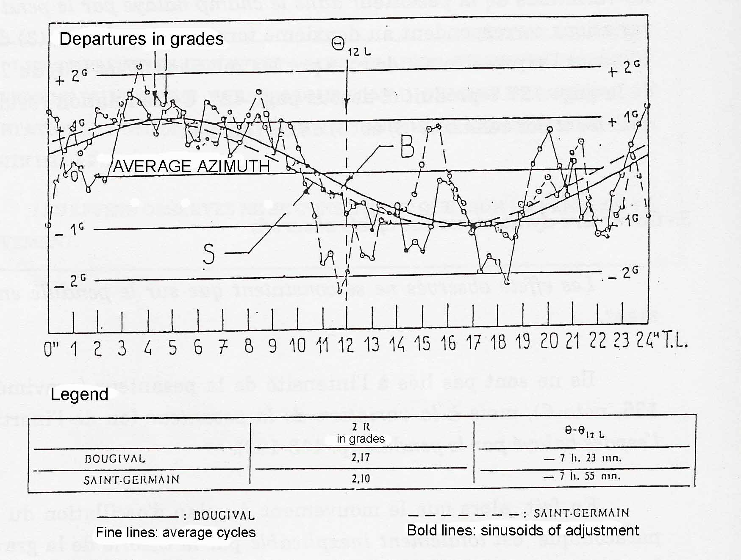
Source: Allais, 1958, Should the laws of gravitation be reconsidered? Complementary Note appended.
The Anisotropy of Space, p. 146.
THE PERIODIC STRUCTURES OBSERVED AT BOUGIVAL AND AT SAINT-GERMAIN CORRESPONDED IN A VERY REMARKABLE MANNER.
THEY SWEPT AWAY ALL PREVIOUS OBJECTIONS.

THE OBSERVATIONS OF THE PARACONICAL PENDULUM WITH ISOTROPIC SUPPORT ENABLE THE PERIODIC STRUCTURE OF THE DIRECTION OF ANISOTROPY OF SPACE TO BE DETERMINED, AND THENCE ENABLE PREDICTION OF THIS DIRECTION OF ANISOTROPY AT A GIVEN PLACE.

THE LETTER OF MAY 1959 FROM PAUL BERGERON TO WERNER VON BRAUN CONFIRMS THE TOTAL IMPOSSIBILITY OF EXPLAINING THE PERCEIVED ANOMALIES WITHIN THE FRAMEWORK OF CURRENTLY ACCEPTED THEORY.

DUE TO THE INCREDIBLE DOGMATISM OF SCIENTIFIC CIRCLES AT THE TIME, SCIENCE HAS LOST AT LEAST FORTY YEARS. NOT ONLY WERE MY EXPERIMENTS NOT FOLLOWED UP, BUT THEY WERE SUCCESSFULLY HIDDEN.

THE HYPOTHESIS OF THE ANISOTROPY OF INERTIAL SPACE LEADS TO THE CONCLUSION THAT, THE LONGER IS THE PENDULUM, THE LESS IS THE FOUCAULT EFFECT DISTURBED.

ANY MECHANICAL ARRANGEMENT FOR KEEPING THE PENDULUM SWINGING AND PREVENTING PROGRESSIVE REDUCTION OF ITS OSCILLATIONS IS COMPLETELY COUNTER-INDICATED.
ONLY A SERIES OF 14 MINUTE LONG OBSERVATIONS OF THE PENDULUM, RELAUNCHING IT EACH 20 MINUTES, IS SUITABLE.

EVERYTHING TAKES PLACE AS THOUGH THE CRITERION L/α² DEDUCED FROM THE HYPOTHESIS OF THE ANISOTROPY OF INERTIAL SPACE IS VALID.
FOLLOWING THIS CRITERION, THE GREATER IS THE RATIO BETWEEN THE LENGTH OF THE PENDULUM AND THE SQUARE OF ITS AMPLITUDE, THE BETTER WILL THE FOUCAULT EFFECT BE VERIFIED.

ALL PREVIOUS EXPERIMENTS UPON THE FOUCAULT PENDULUM HAVE PRESENTED ANOMALIES WHICH HAVE NEVER BEEN EXPLAINED.
by approaching experiments upon the pendulum in a different manner, i.e. via continuous observations over periods of a month and harmonic analysis of their periodic structure, my own experiments have made it possible to surmount the incessant difficulties encountered by the observers of the 19th and 20th centuries.

ABOVE ALL, EFFECTIVE REPLICATION OF MY EXPERIMENTS REQUIRES IMPLEMENTATION OF IDENTICAL EXPERIMENTAL CONDITIONS.

If experimental conditions are set up which are identical to those I employed with the paraconical pendulums with anisotropic support and with isotropic support, it is absolutely certain that the existence of all the observed anomalies, and also their mutual interconnections, will be confirmed.

The SUGGESTED EXPERIMENTS would make it possible to determine the direction of spatial anisotropy, and to predict this anisotropy direction, at any given point, as is the case with tides today.

implementation of 14 minute experimentS with releases every 20 minutes is an INDISPENSABLE condition, whether the process of chained series or the process of mobile correlations is considered.
ANY ARRANGEMENT FOR MAINTAINING THE AMPLITUDE AUTOMATICALLY SHOULD BE COMPLETELY EXCLUDED.

THE ANTICIPATED COST FOR IMPLEMENTING A MONTH-LONG SERIES OF OBSERVATIONS OF THE PARACONICAL PENDULUM WITH ANISOTROPIC SUPPORT WOULD BE MUCH LESS THAN THE COST ATTRIBUTABLE TO ALL THE OBSERVATIONS OF THE TOTAL ECLIPSE OF 11 AUGUST 1999.
SUCH A MONTH-LONG SERIES OF OBSERVATIONS WOULD YIELD MUCH MORE COPIOUS AND VALUABLE DATA THAN ALL THE OBSERVATIONS OF THE TOTAL ECLIPSE OF 11 AUGUST 1999.

A first month-long series OF CHAINED OBSERVATIONS WITH A PARACONICAL PENDULUM WITH ANISOTROPIC SUPPORT WOULD confirm the existence of the periodic LUNI-SOLAR components which I discovered.
IT WOULD THUS BE POSSIBLE TO DECIDE UPON FURTHER EXPERIMENTS WITH FULL KNOWLEDGE OF THE FACTS.

WITH THE ISOTROPIC SUPPORT, TWO EXPERIMENTAL PROCEDURES WILL ENABLE THE DIRECTION OF ANISOTROPY OF SPACE TO BE DETERMINED:
- THE PROCESS OF MOBILE CORRELATIONS;
- THE PROCESS OF CHAINED EXPERIMENTS.
THESE TWO PROCESSES ARE INDEPENDENT AND COMPLEMENTARY.

trying new experimental conditions, in particular using very short pendulums with large amplitudes, should not be considered before repeating my experiments with the paraconical pendulum with THE anisotropic and THE isotropic support.

